Project Report

|  |  |
| --- | --- |
| Product Name | Advanced Certificate in Web Development |
| Qualification Name (NICF) | NICF-Advanced Certificate in Infocomm Technology (Software & Applications) |
| Product Name | Web Development Foundations |
| Module Name (NICF) | NICF -Web Development Foundations |

|  |  |  |  |
| --- | --- | --- | --- |
| Student name | | Assessor name | |
| Wildan Luqmanul Hakim | | Arvinder Kaur | |
| Date issued | Completion date | | Submitted on |
| 12 September 2022 | 21 September 2022 | | 21 September 2022 |
|  | |  | |
| Project title | Design, Develop, Implement & Document Community Portal Website | | |

|  |
| --- |
| Learner declaration |
| I certify that the work submitted for this assignment is my own and research sources are fully acknowledged.    Student signature: Date: 21 September 2022 |

Content

1. Project background
2. Project Objectives
3. Task 1
4. Task 2
5. Task 3
6. Task 4
7. Task 5
8. Task 6
9. Task 7
10. Task 8
11. Task 9
12. Task 10
13. Task 11
14. Project Background

We have been approached by ABC Jobs Pte Ltd to develop a community portal for software developer. ABC Jobs Pte Ltd is a website development company, this company has a new project to develop a website for Community Portal similar to Linked.in, in this project ABC Jobs requires a scenario for users to register on the registration page, users can search for other users with various parameters such as First Name, Last Name, Company Name, City and Country. Users will be able to view the Public Profile of users after searching them. The portal allow users to login, request for forgotten password and Update their profile information.

In the project in this module to develop a ABC Jobs using Jsp, CSS, JavaScript, and Spring.

Also save value or data users into database MySQL

1. Project Objective

We need to design, develop, implement, test and document for ABC Jobs community

Portal using spring framework.

1. Allow the programmers to register in the portal, show a thank you page & send a registration confirmation email.
2. Search & Find Other Programmers after login and view their profile.
3. Provide Login Page
4. Provide password retrieval functionality.
5. Update their Profile after logging in.
6. There are 2 types of users in this Community portal. They are Software Programmer and Administrator.
7. Task 1
8. Task Statement (a): Block diagram of the system

Solution:

Case diagram

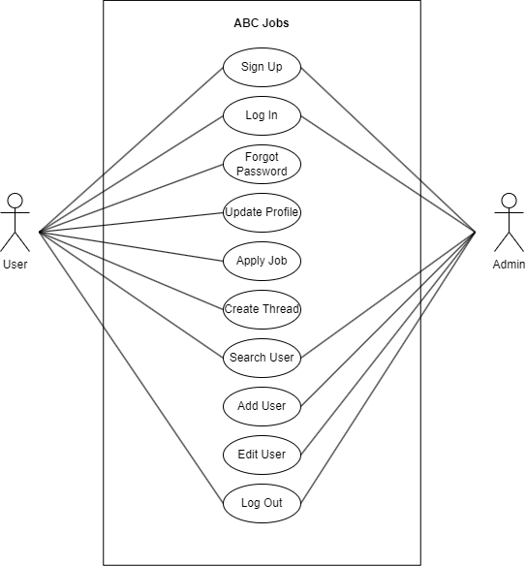

Activity diagram - Registration

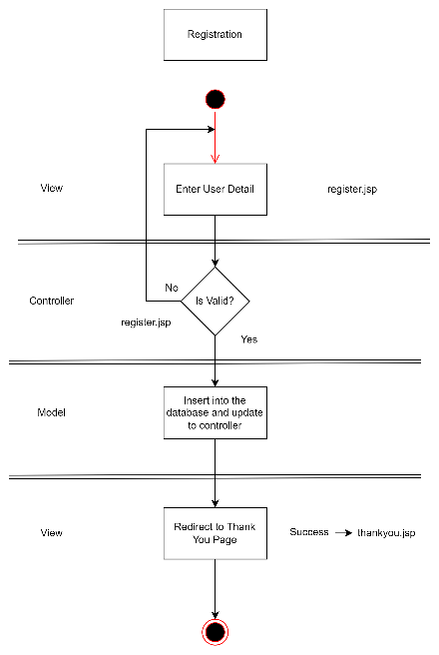

Activity diagram - Login

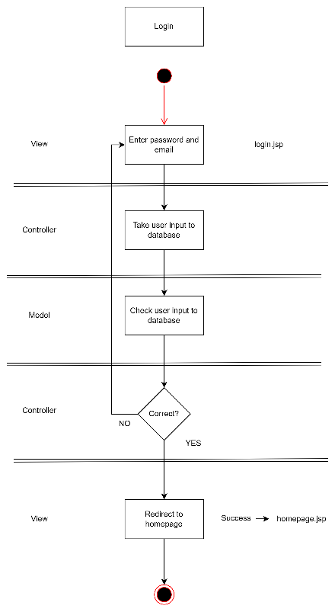

Activity diagram – Forgot Password

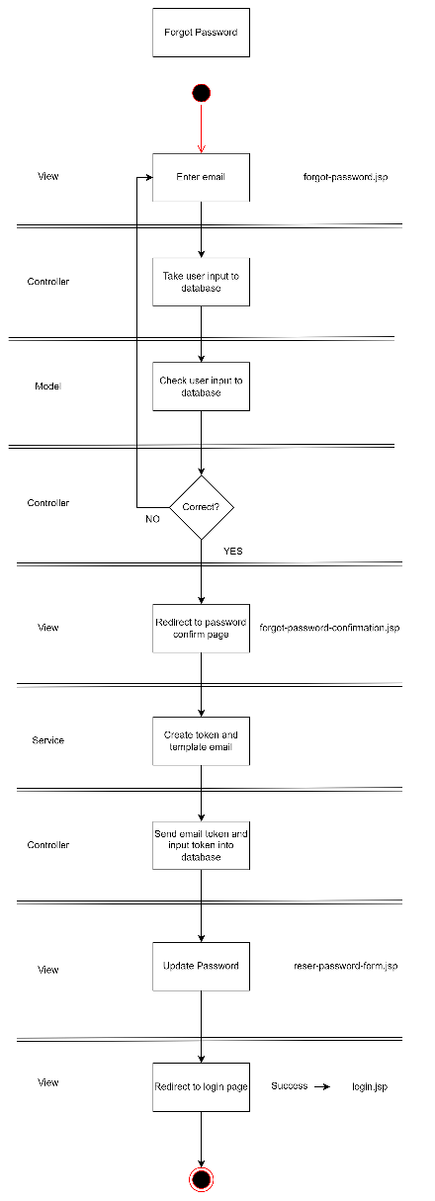

Activity diagram – Search

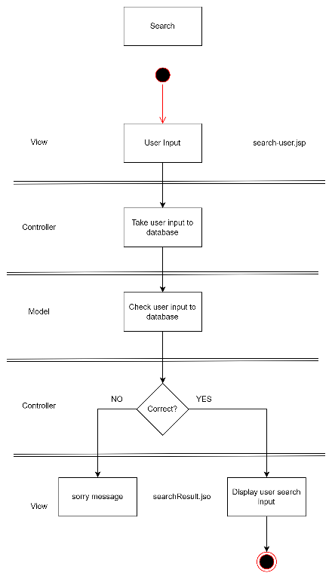

Activity diagram – Update Profile

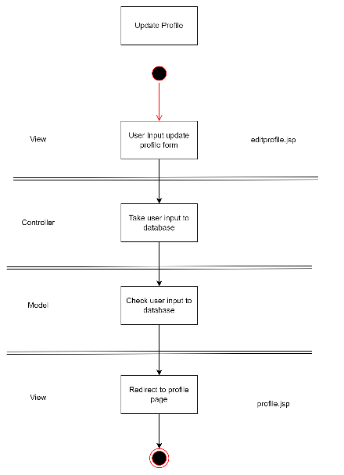

Task Statement (b): Architecture of the system

Solution:

1. Explain the Architecture of the application

Step 1 − The client browser sends request to the MVC Application.

Step 2 – Application receives this request and performs routing based on the URL of the incoming request

Step 3 − This routing operation calls the appropriate controller and executes it

Step 4 − The Controller request the data using Model and execute the appropriate service

Step 5 – Database respond the service by giving an appropriate data

Step 6 – The required data displayed on the view

1. System
   1. List down all the modules to be developed
      * Private Module - Administrator - Manage user Data
      * Public Module - Software Programmers – Register, Login, Forgot Password, Update Profile, and Search other user
   2. List down all the pages in each of the modules and briefly describe the purpose

* Private Module – Administrator

1. Admin Dashboard : Display all user in ABC Jobs
2. Admin Add : Display form to add new user or admin
3. Admin Edit : Display form to edit user or admin
4. Admin Profile : Display admin profile

* Public Module - Software Programmers

1. Home : Display home page
2. Register : Display form to register on ABC Jobs
3. Register Thank You : Display thanks greeting after register
4. Login : Display form to login on ABC Jobs
5. Forgot Password : Display form to input email user for reset their password
6. Forgot Password Confirm : Display confirm email page and email will be send into user email
7. Profile : Display profile user
8. Update Profile : Display form to update profile user
9. Search User : Display search box and display other user profile after input search by first name, last name, company, city, and country
10. Search User Result : Display other user account
11. View Profile : Display other user profile detail
    1. Note down which are Create, Edit & View pages.

Insert - Create Page for users to register and data are inserted into database

* + Register
  + Add user

Select - View Page for the users can view the others profile page

* + Search result

Update - Update Page for the user to edit and update their profile page

* + Update user
  + Edit
  + New password

|  |  |  |  |
| --- | --- | --- | --- |
| a. Module | b. Pages | Brief description | c. Operations |
| Common | footer.jsp | Copyright, company name, privacy policy and sitemap | View |
| Common | navbar.jsp | Logo, Hyperlink, Button | View |
| Common | navbar-admin.jsp | Logo, Hyperlink, Button | View |
| Common | navbar-loggedin.jsp | Logo, Hyperlink, Button | View |
| Common | header.jsp | Head tag HTML |  |
| Public | home.jsp | Navbar, footer, banner, | View |
| Public | homepage.jsp | Navbar, footer, banner | View |
| Public | register.jsp | Navbar, footer, register form | View |
| Public | thankyou.jsp | Navbar, footer, thank you message | View |
| Public | login.jsp | Navbar, footer, login form | View |
| Public | forgot-password.jsp | Navbar, footer, email form | View |
| Public | forgot-password-confirmation.jsp | Navbar, footer, confirm token message | View |
| Public | profile.jsp | Navbar, footer, user profile detail | View |
| Public | editprofile.jsp | Navbar, footer, update user form | View |
| Public | search-user.jsp | Navbar, footer, search form | View |
| Public | search-result.jsp | Navbar, footer, search form, search result | View |
| Public | view-profile.jsp | Navbar, footer, other user profile detail | View |
| Private | admin-add.jsp | Navbar, add user form | View |
| Private | admin-dashboard.jsp | Navbar, list all user | View |
| Private | admin-edit.jsp | Navbar, edit user form | View |
| Private | admin-profile.jsp | Navbar, admin profile deatail | View |

* 1. Create the Sitemap of Public & Private Site

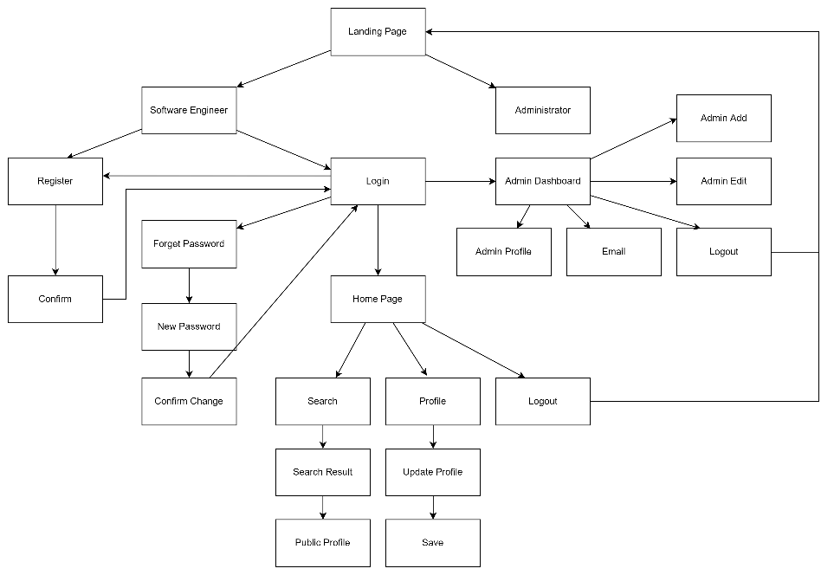

1. Technical Environment Requirements

Hardware Requirements

* + - * Database server – MySQL server
      * Firewall settings - Port 8080 -- Http

- Port 3306 – Database

Software Requirements

Development environment- JDK 18.0.2.1

Framework Spring 5

Database server- MySQL Server

1. System Integration Requirements

JDBC - JDBC Connector 8.0.22

1. Portability Requirements

Multi OS- Windows, Linux, and Mac

Multiple Browsers - Chrome, Safari

Multiple Devices - Desktop, Tablet, Mobile

1. Maintainability Requirements
   * + - Backup the database for every 6 hours.
       - Vulnerability check – periodical scanning.
       - Each request should be processed with 10 seconds.
2. Performance Requirements

Concurrent number of users- 100

Loading time – 15secs

1. Security Requirements
2. List down the Security Access for the different kind of users
3. User have different email and password with other user
4. User have role to distinguish admin and software engineers
5. Briefly explain Login & Logout mechanism

* Login : When user enter their email & password the application do checking if the email password is valid and check role of the user registered in database. If the user are exist in database user will get a HttpSession when login and directed to apropriate page based on role
* Log out : The HttpSession will be terminated and user will be back to landing page

Task 2

Task Statement:

1. Install Eclipse in your laptop



1. Provide Screen capture of eclipse IDE

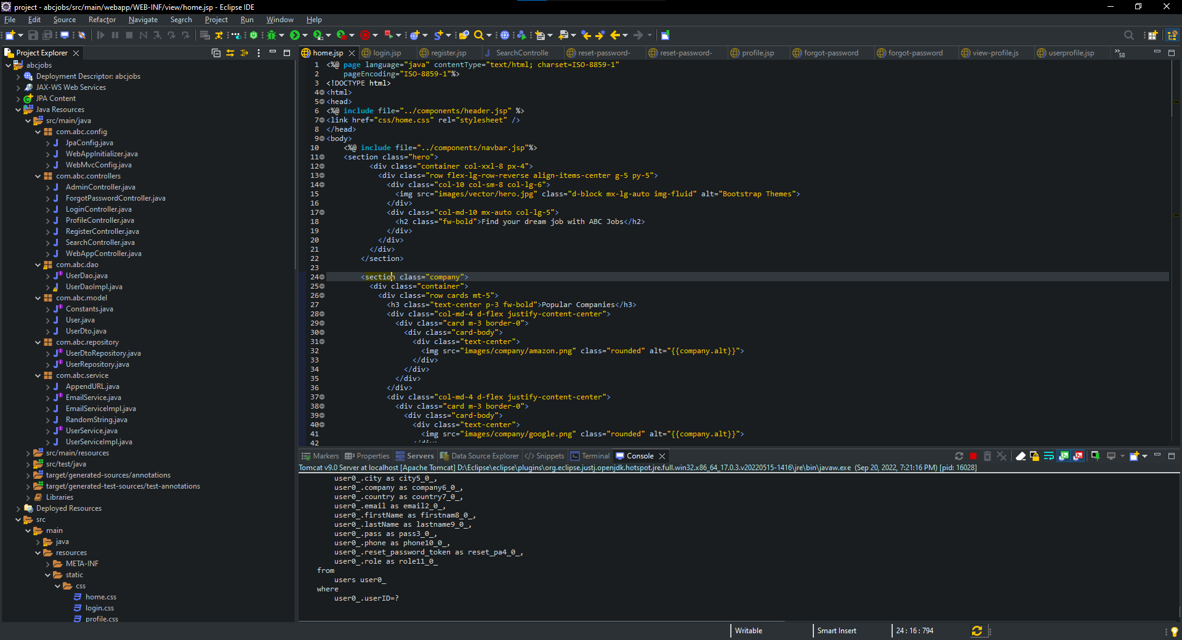

1. Task 3

Task Statement:

1. Provide description of 3 features in IDE along with the screen capture of their use.

Three IDE features are

* Debuging

The Eclipse Java IDE provides many debugging tools and views grouped in the Debug Perspective to developers debug effectively. It allows developers to easily set breakpoints, start and stop the running application, or perform various debugging activities.In most cases, developers can edit and save the code while debugging without restarting the program.

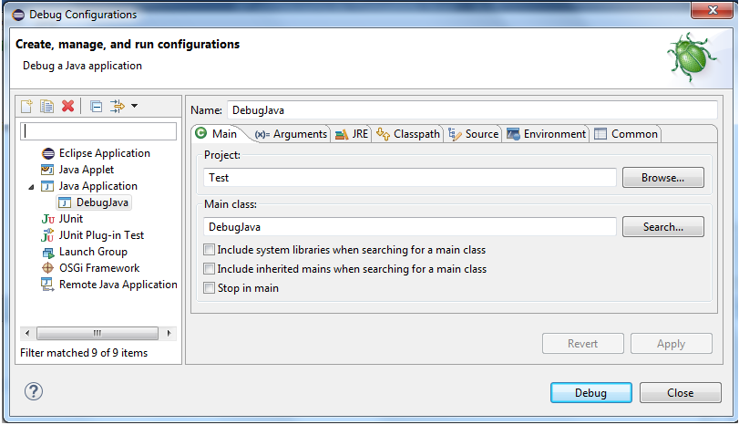

* Local History

Allows you to retrieve and store source code. Every time you modify a file, a copy of the old contents is stored in the local history. You can compare or replace a file with any older version from the history at any time. Although this is no replacement for a real code repository, it can help you out when you change or accidentally delete a file.

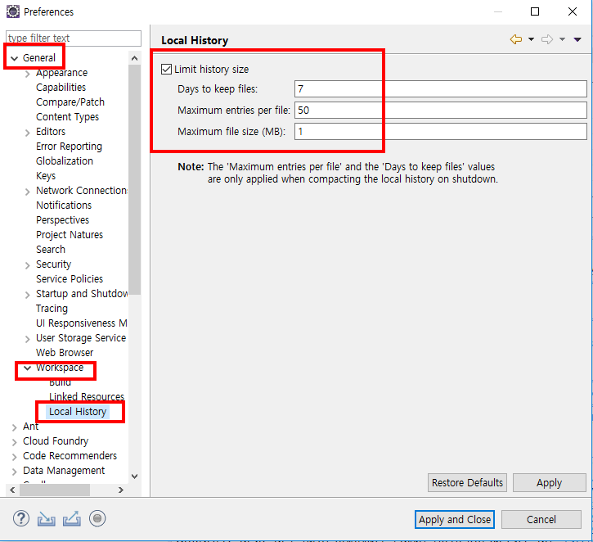

* Code Insight

The identification of functions and keywords for any specific programming language is a vital part of any kind of IDE platform. The plug-ins are available for each programming language in the Eclipse IDE so it is easy to identify the keywords and build apps on this platform

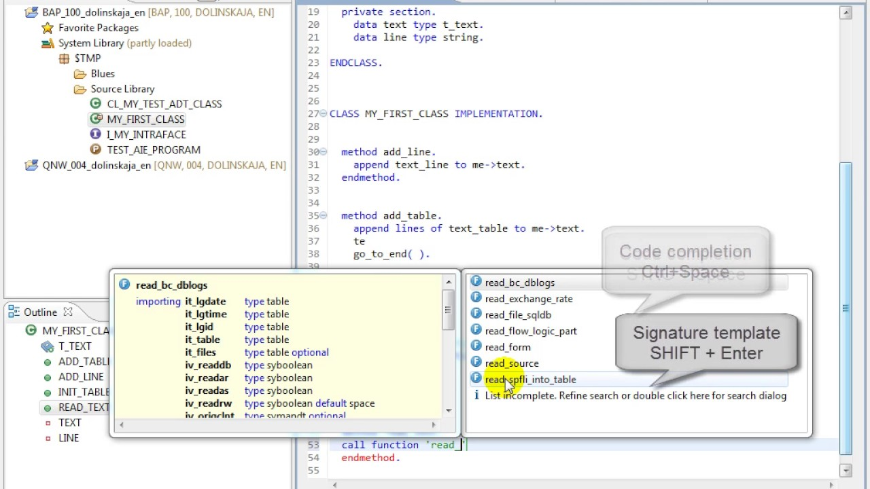

1. Include it as part of Project Presentation
2. Task 4

Task Statement

Create the following items in “Coding & Documentation Standards” Section in Project Report

1. List 5 Coding Standards & Conventions to be used and explain shortly.

* Naming Convention

Class Name - Class names should be nouns, in mixed case with the first letter of each internal word capitalized.

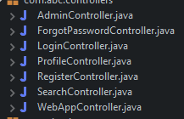

* Identantion

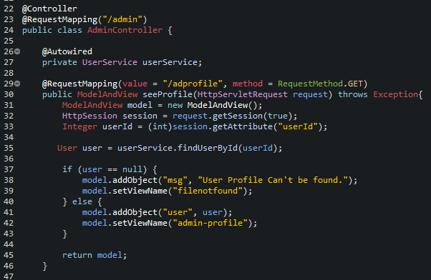

* Error return values and exception handling conventions

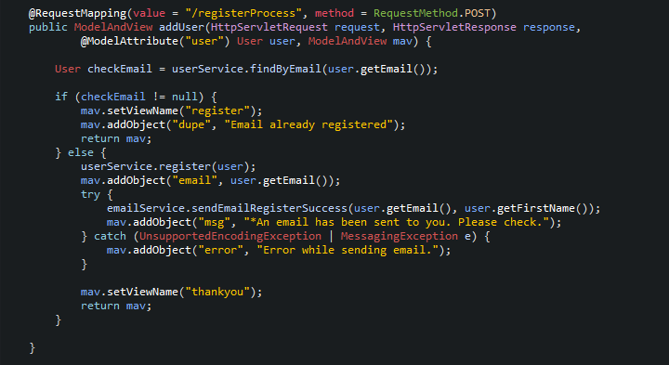

* Avoidusing an identifier for multiple purposes

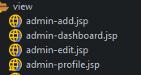

* Use coding style that is not too difficult to understand

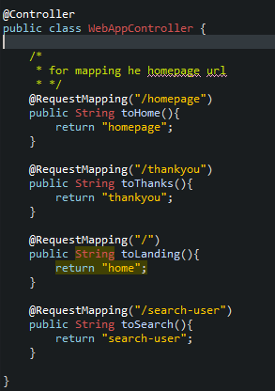

1. Describe briefly documentation tool, you will be using and its configuration.

Solution

Go to Project -> Generate Java Doc ->choose the location of Javadoc->finish.

Generate the doc file in the desired location.

1. Task 5 (Views)

Task Statement

1. Develop the following pages in HTML (Developed in Module 3) (source code)
   1. Home Page
   2. Create/Edit Page
   3. Listing Page
   4. Login/Logout
   5. Forget Password screen
   6. Administration Page
2. Template them by separating Headers/ Footers and including them using Server Side includes.

(header.jsp and footer.jsp) (include)

1. Provide the screen capture in Project Presentation

Solution

1. Home Page

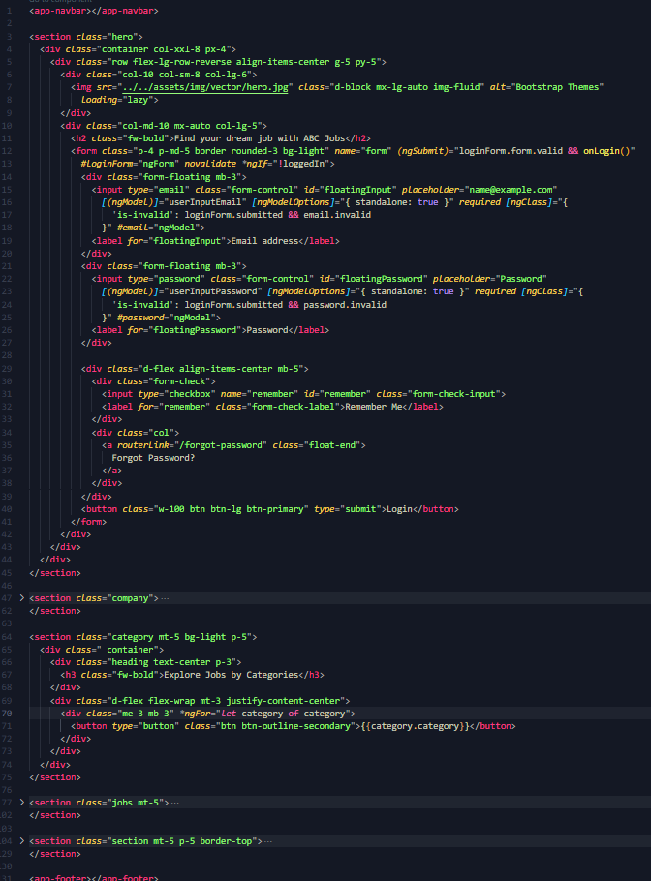

1. Create/Edit Page

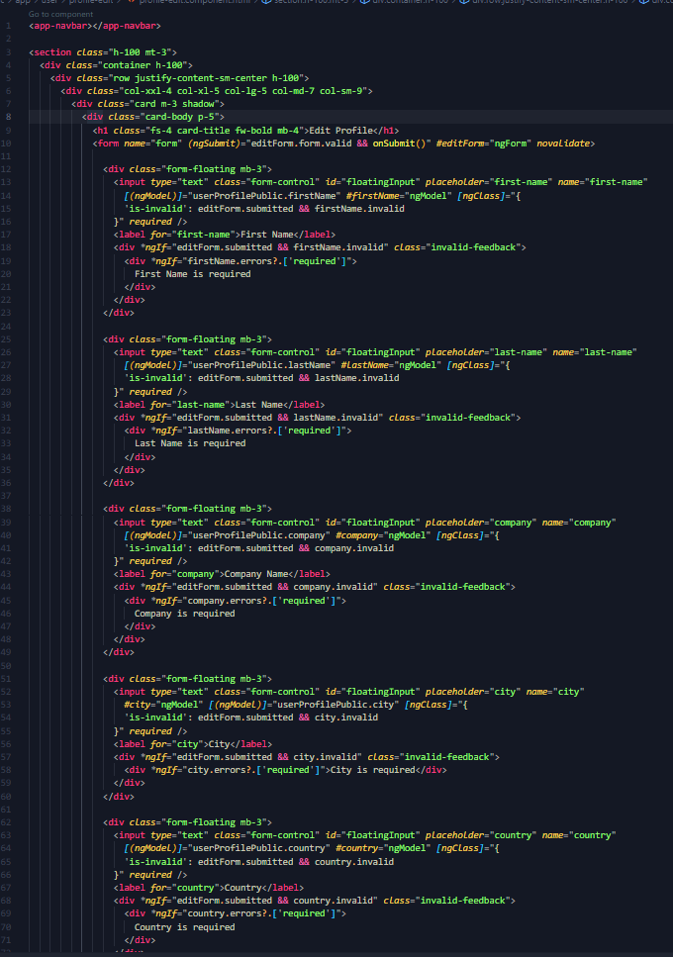

1. Listing Page

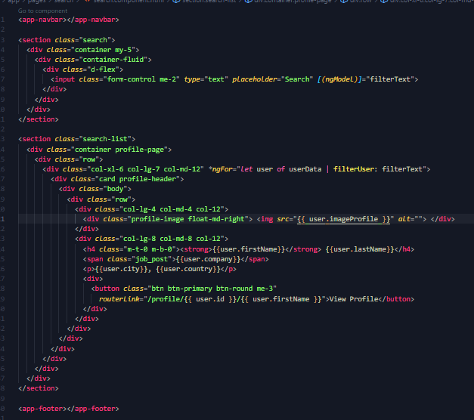

1. Login/Logout

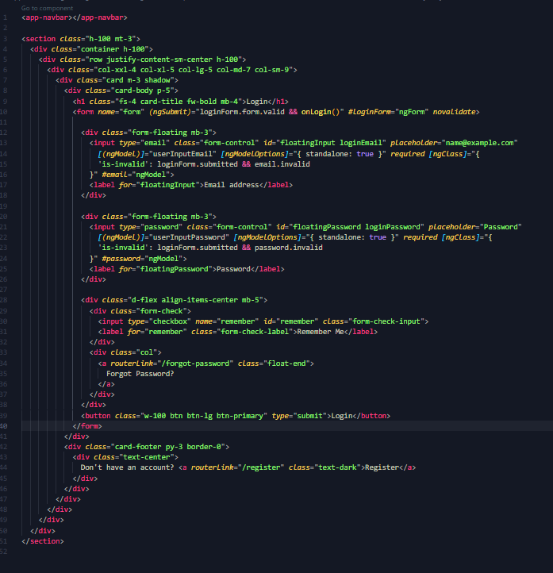

1. Forget Password screen

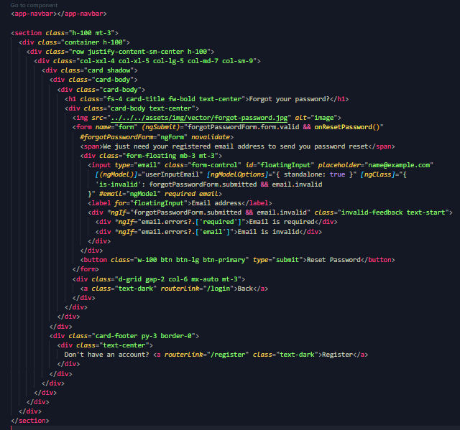

1. Administration Page

1. Task 6 (java classes)
2. Package wise
3. MainCotroller.java

Source code

Task Statement:

1. Create the required classes in Java

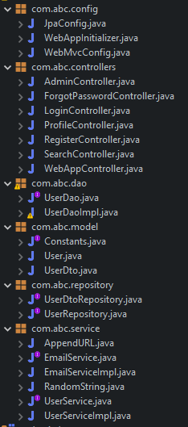

1. Include the Data Access Layer classes

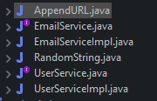

1. Include samples as part of Project Report

1. Task 7

(screen capture of your working website – web pages)

Task Statement:

Provide screen capture of developed pages and hosted application in Project Presentation

1. Use Queries, Procs Developed in Module 4

Users table

|  |  |  |  |  |  |  |
| --- | --- | --- | --- | --- | --- | --- |
| **Field Name (Column)** | **Data Type** | **Field Size** | **Key (Constraint)** | **References** | **Nullable** | **Default Value** |
| UserID | INT | 11 | Primary Key |  | No | Auto Increment |
| firstName | VARCHAR | 50 | Not Null |  | No |  |
| lastName | VARCHAR | 50 | Not Null |  | No |  |
| email | VARCHAR | 50 | Not Null |  | No |  |
| pass | VARCHAR | 50 | Not Null |  | No |  |
| country | VARCHAR | 50 | Not Null |  | No |  |
| city | VARCHAR | 50 | Not Null |  | No |  |
| company | VARCHAR | 200 | Not Null |  | No |  |
| phone | VARCHAR | 20 | Not Null |  | No |  |
| role | INT | 1 | Not Null |  | No |  |
| reset_password_token | VARCHAR | 20 | Not Null |  | No |  |

1. Develop the Models, Views, Controller (at least for one of the functionality, better if you can use for all the functionality)

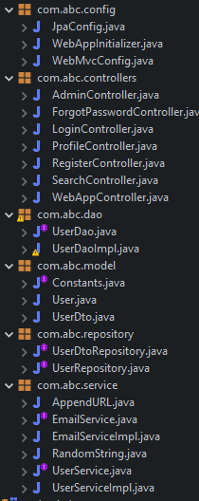

1. Develop Home Page & Integrate with Login System

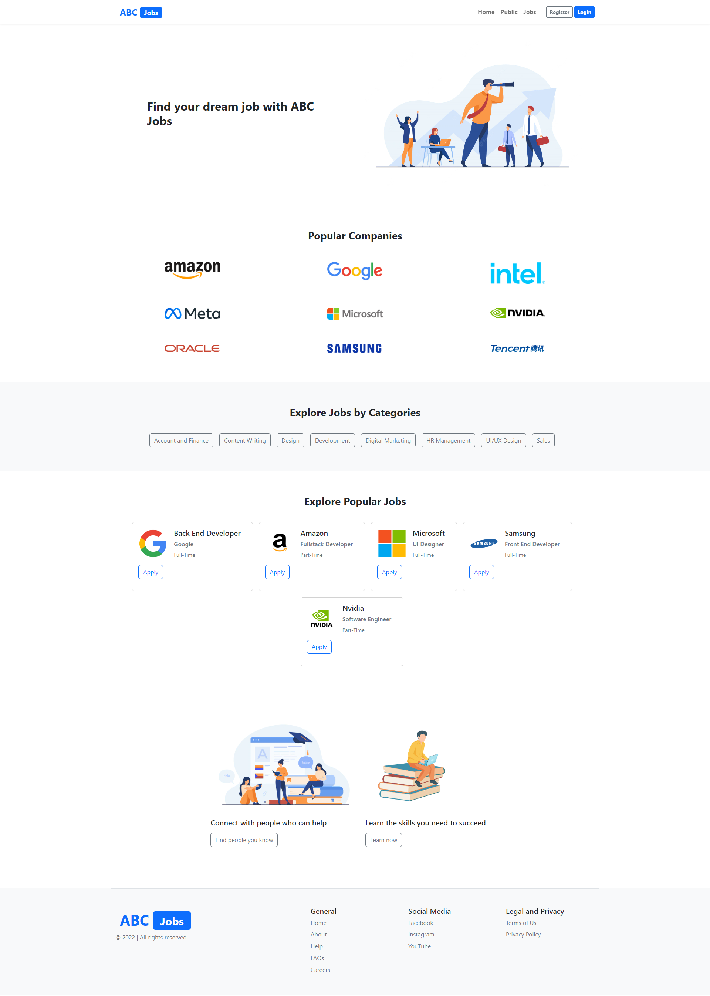

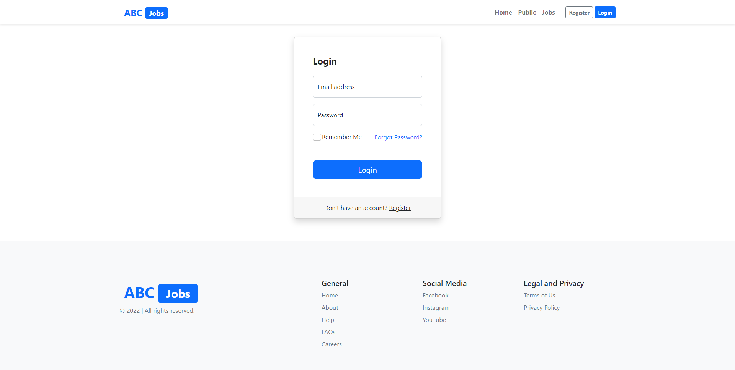

1. Develop Registration Form & Registration Thank You

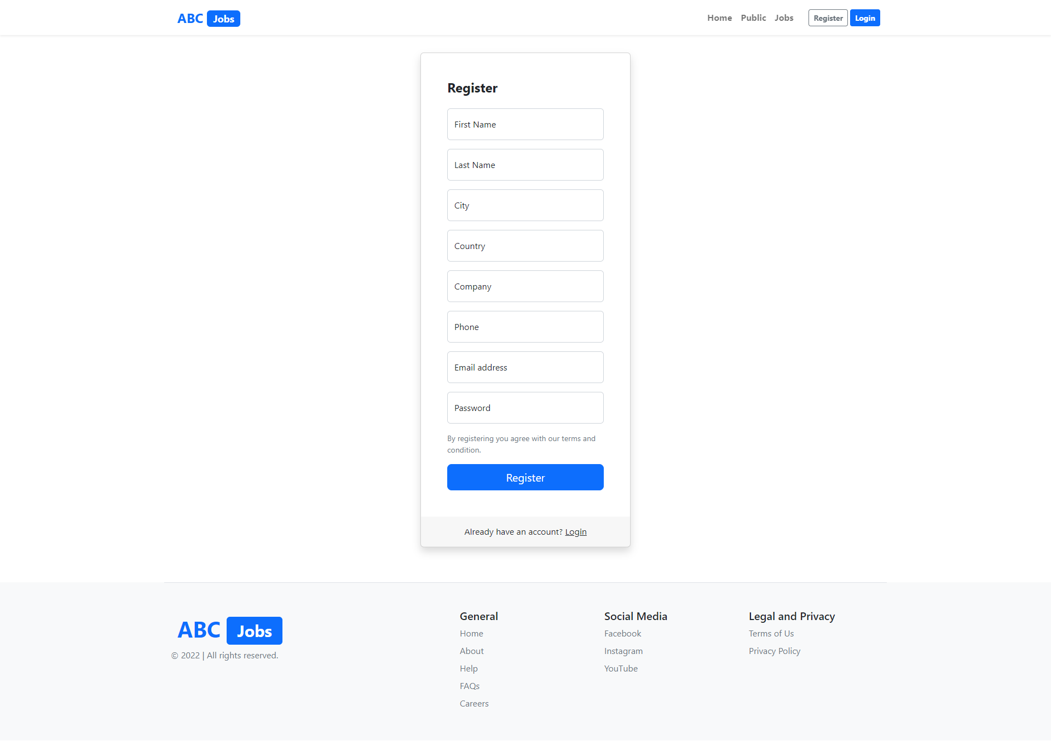

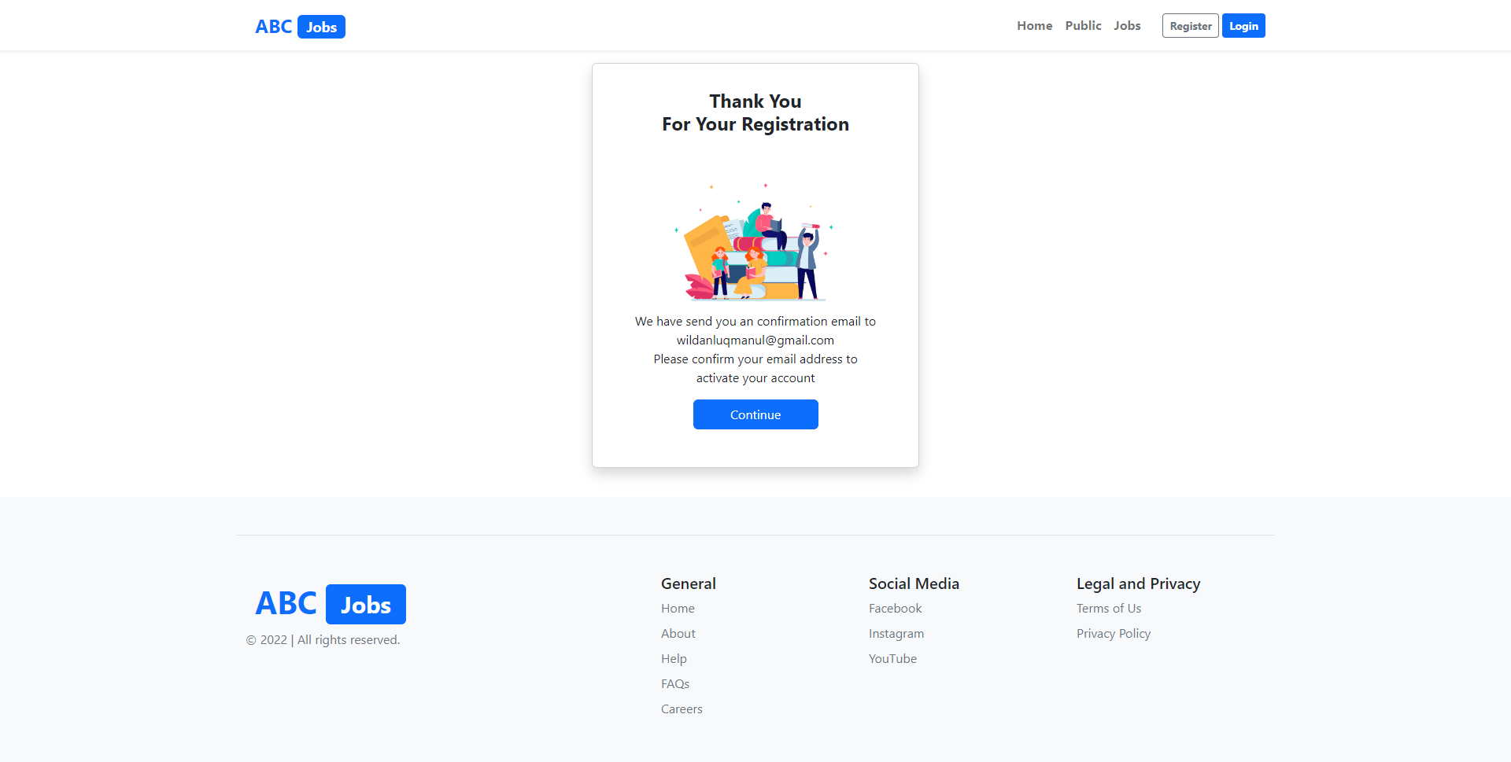

1. Develop Forget Password mechanism

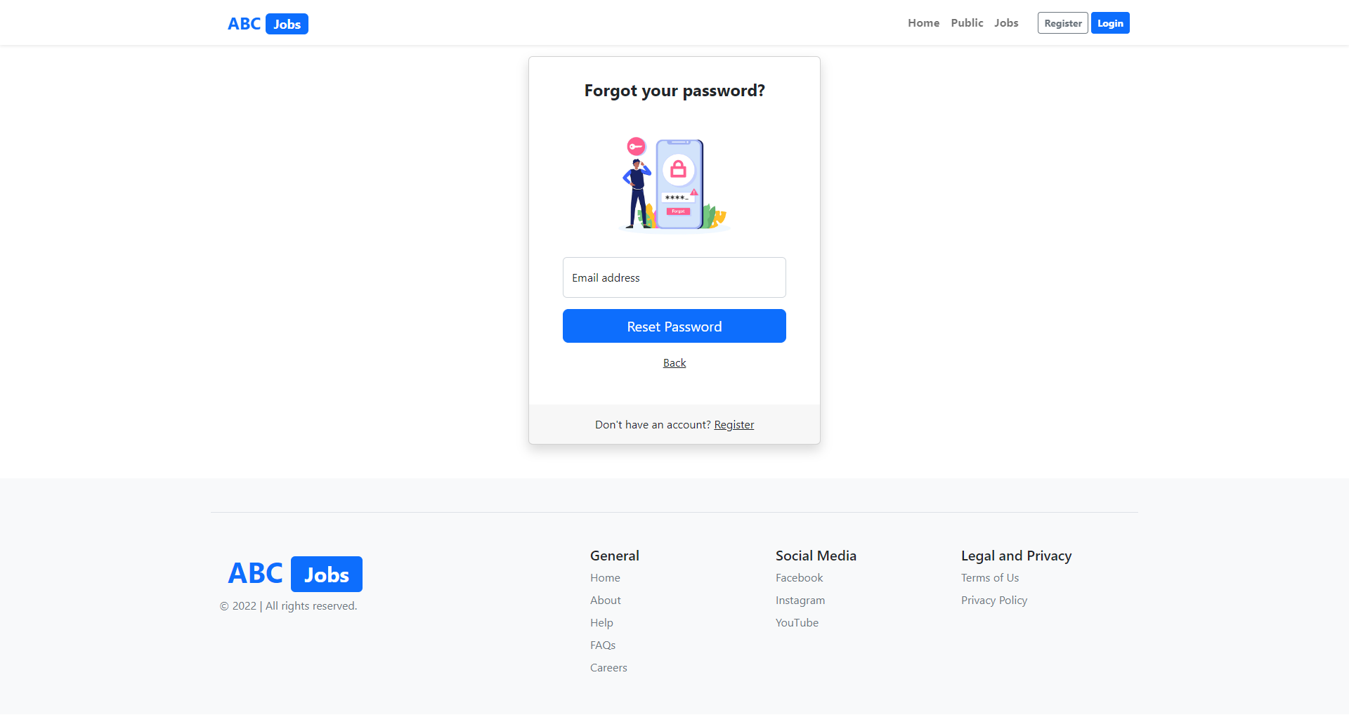

1. Develop Landing Page post login

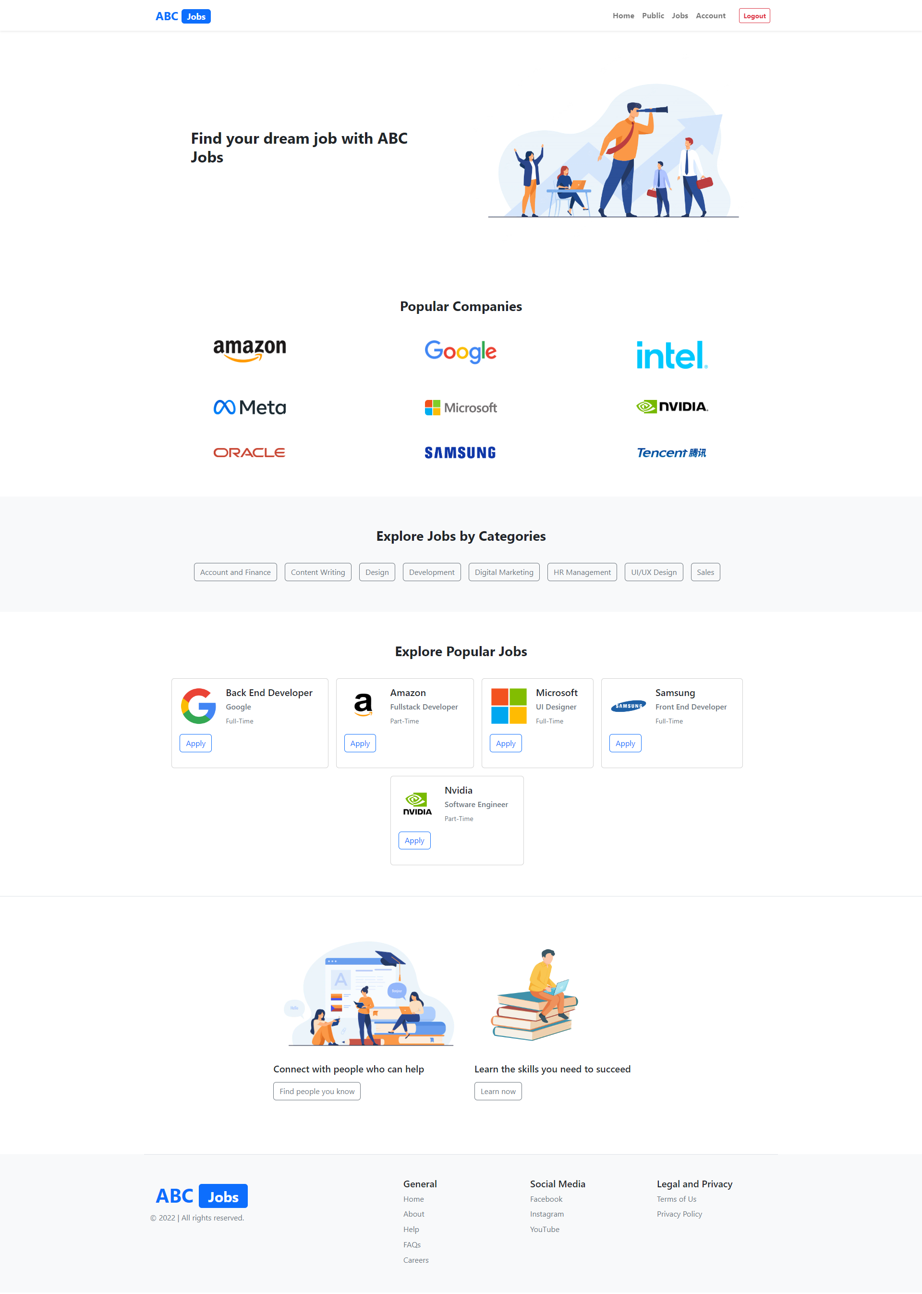

1. Develop Search Box for Users

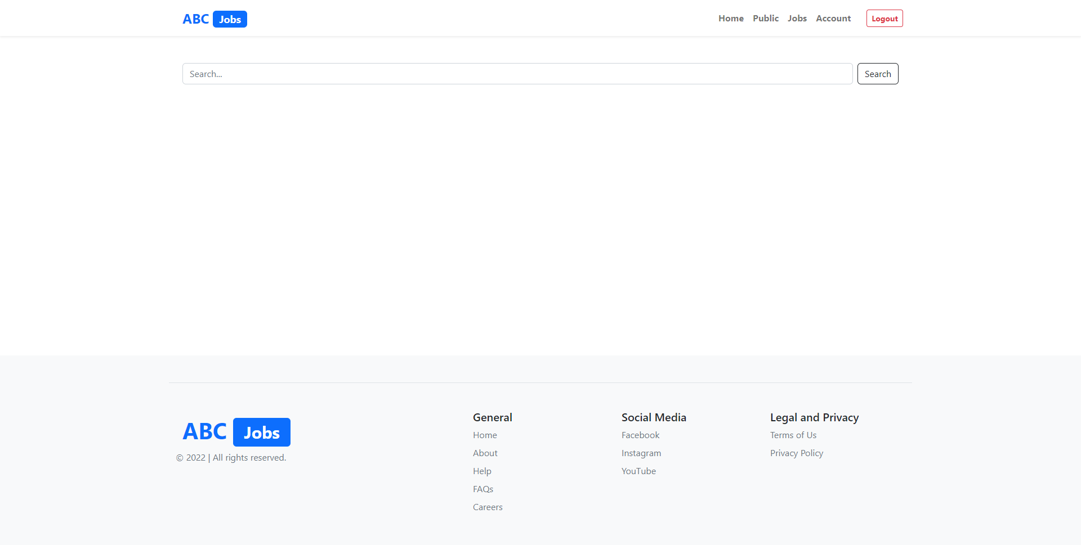

1. Develop View Search Results

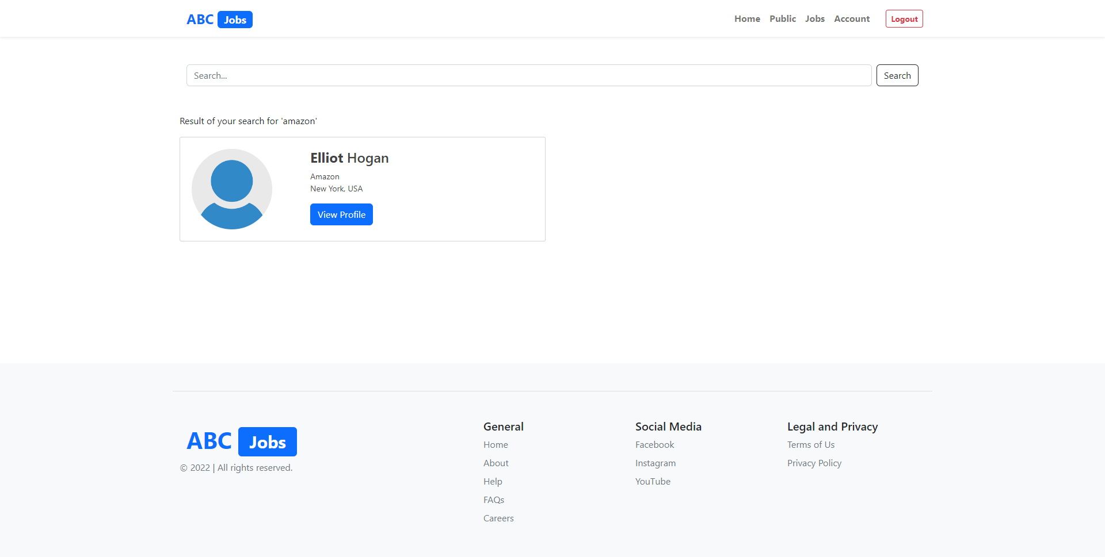

1. Develop View Profile Page

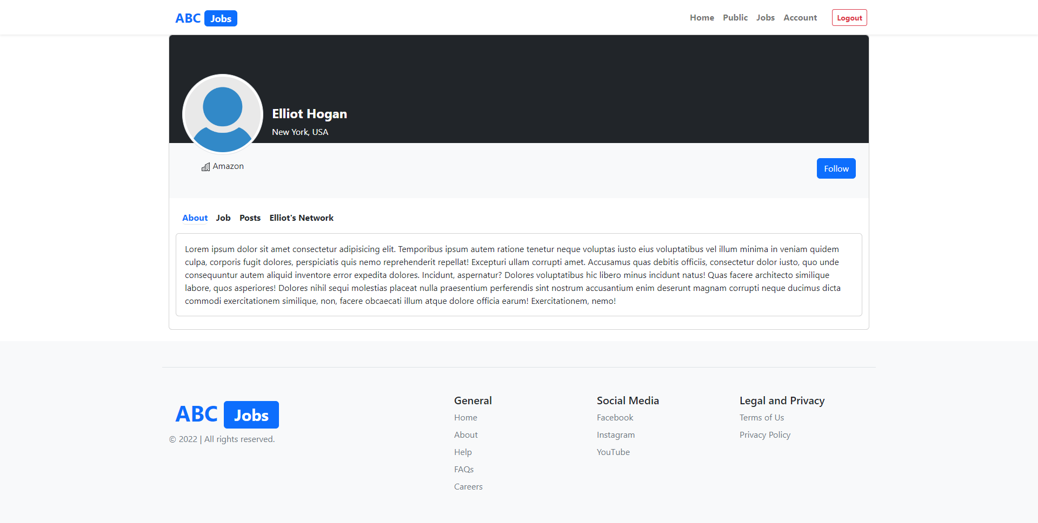

1. Develop Edit Profile Functionality

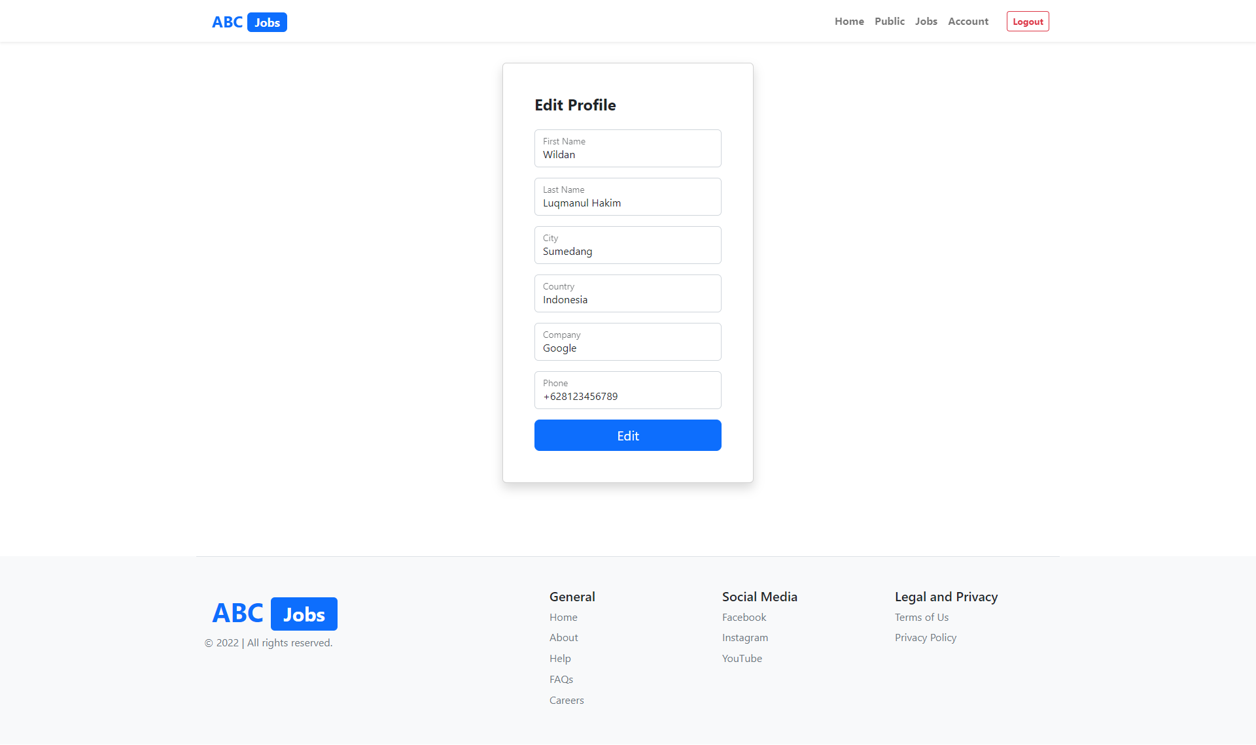

Solution

1. Task 8

Task Statement:

1. Debug the application in Eclipse

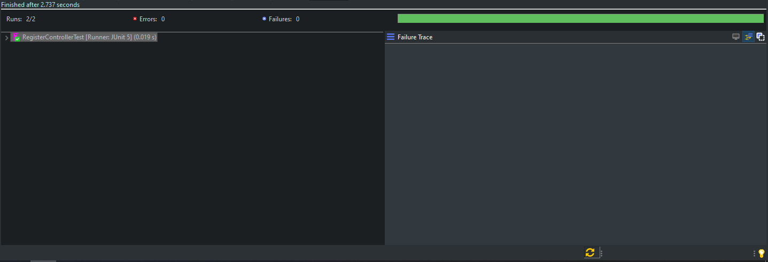

1. Provide the screen capture of your application code in Eclipse Debug Mode include it as part of Project Presentation
2. Task 9

Task Statement:

1. Provide screen capture of 3 Errors you encountered while developing the application.
2. Include it as part of Project Presentation

|  |  |
| --- | --- |
| **Error** | **Error handling (Solution)** |
|  | - Look at HTTP Status  - Check out the Root Cause  - Look at the last sentence  - Unable to create requested service [org.hibernate.engine.jdbc.env.spi.JdbcEnvironment]  - Likely caused by JDBC or repository interfaces  - Check persistence.xml  - Fixed jdbc:mysql://localhost:5306 to jdbc:mysql://localhost:3306 |
|  | - Look at HTTP Status  - Check out the WebAppConfig.java  - Make sure@ComponentScan same with grupid project  - Fixed com.abcjobs to com.abc |
|  | - Look at HTTP Status  - Check out the Root Cause  - Look at the last sentence  - Unable to create requested service [org.hibernate.engine.jdbc.env.spi.JdbcEnvironment]  - Likely caused by JDBC or repository interfaces  - Check persistence.xml  - Fixed jdbc:mysql://localhost:3306/abc to jdbc:mysql://localhost:3306/abcjobs |

1. Task 10

Task Statement:

1. Propose & Document a New feature to the application .
2. Develop the new feature and provide a report.
3. Include it as part of Project Report.

Solution

Before : ABC jobs can’t send registration-thankyou email

After : ABC Jobs can send registration-thankyou email

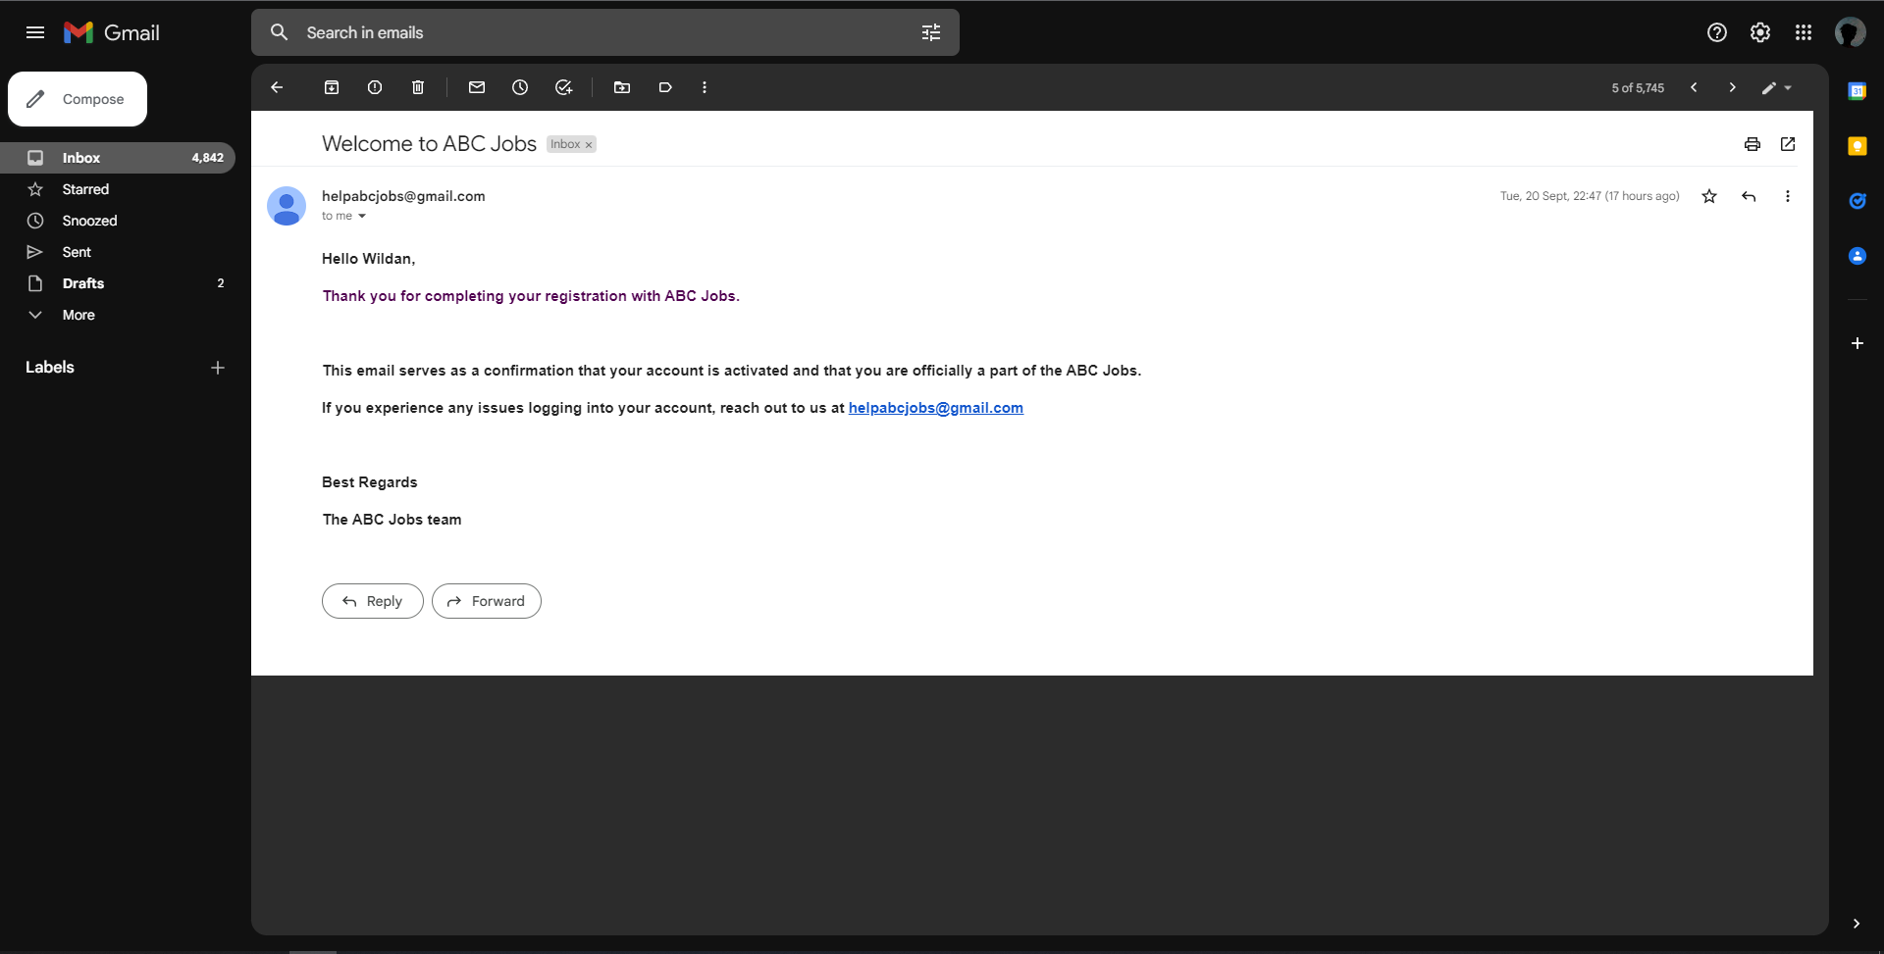

Before : ABC Jobs can’t do search another user

After : ABC Jobs can do search another user



Before : ABC jobs can’t send forgot password confirm email

After : ABC Jobs can send forgot password confirm email

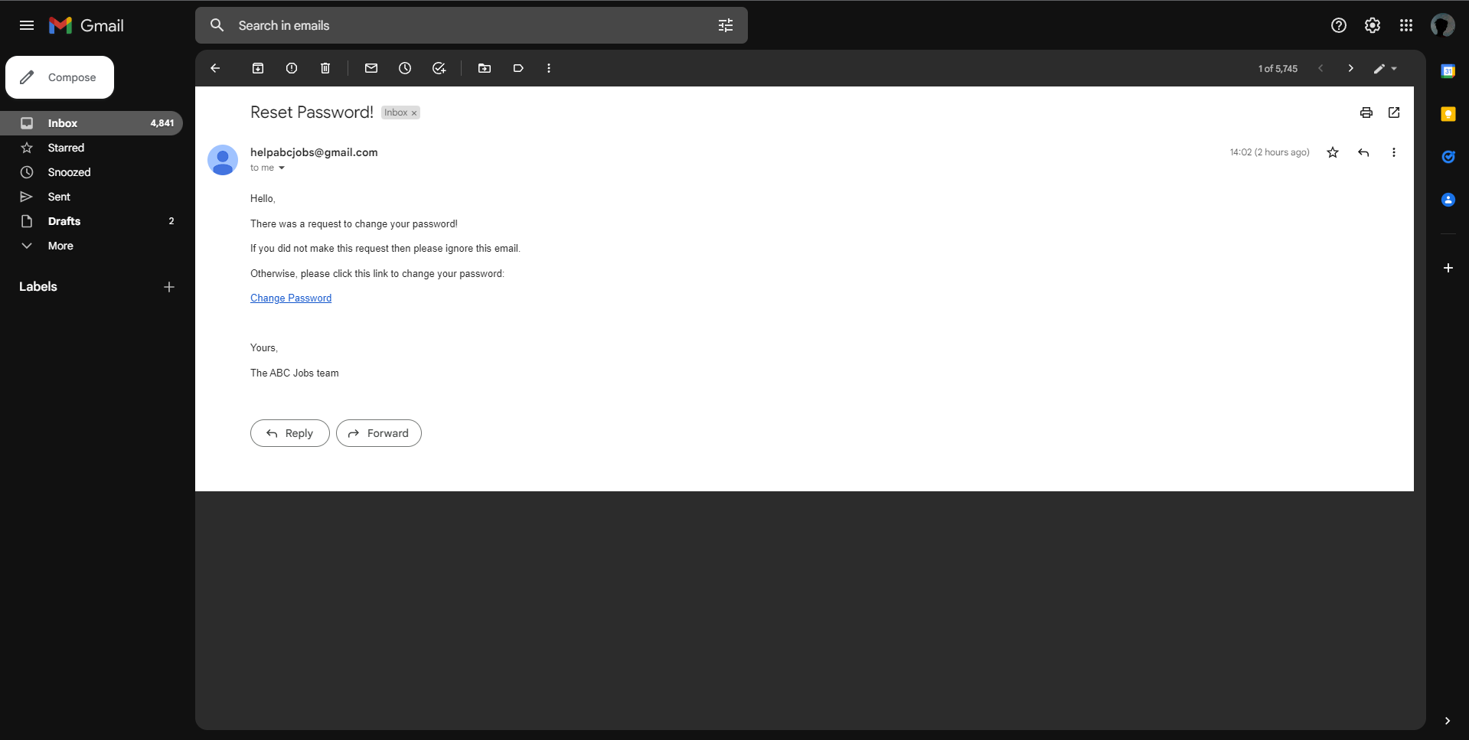

1. Task 11

Task Statement:

Provide Unit Testing code & screen capture of Eclipse IDE in debug mode.

|  |  |  |  |  |  |  |  |  |
| --- | --- | --- | --- | --- | --- | --- | --- | --- |
| Scenario ID | Test Case ID | Test Case | Preconditions | Test Step | Test Data | Expected Results | Actual Results | Pass / Fail |
| TS002 | UATC01 | Check each hyperlink menu is loading correct page | The website is configured to Microsoft Edge by Apache Tomcat Server. | 1. Go to Google Chrome. 2. Type www.abcjobs.com and enter. | Click on Register link  Click on Login link  Click on Public link  Click on Reset password link | Loaded registration page  Loaded Login page  Loaded Search Profile page  Loaded Reset Password page | As expected | Pass |
| TS002 | UATC02 | Log-in to community portal with the account that has been created | The website is configured to Browser by Apache Tomcat Server. | 1. Go to Google Chrome 2. Type www.abcjobs.com and enter. 3. User will landing on Home Page 4. Click Log-in button | registered username and password | User will be redirect to user profile page | As expected | Pass |
| TS002 | UATC03 | Reset the password | The website is configured to Browser by Apache Tomcat Server. | 1. Go to Google Chrome 2. Type www.abcjobs.com and enter. 3. User will landing on Home Page 4. Click Log-in button 5. Click Forget Password button | Registered email address | User will be redirect to Forget Password Confirmation page | As expected | Pass |